**<Hotel Search Engine>**

**Software Requirements Specification**

**<CEN 3031, Fall, 2018>**

**Modification history:**

|  |  |  |  |
| --- | --- | --- | --- |
| Version | Date | Who | Comment |
| v1.0 | 10/9/2018 | Alejandro, Robbie | Added more shall statements, use case diagram, program description, use case descriptions, and assumptions |
| ... |  |  |  |

**Team Name:** Software Operations Specialists

**Team Members:**

* Alejandro Sanchez Padron asanchezpadron0512@gmail.com
* Allen Telson atelson6767@eagle.fgcu.edu
* Flornaldine Pierre fpierre1202@eagle.fgcu.edu
* Chris Bicknese cwbicknese8220@eagle.fgcu.edu
* Robert Darrow rwdarrow4582@eagle.fgcu.edu

**Contents of this Document**

Introduction

* Software to be Produced
* Definition, Acronyms, and Abbreviations

Product Overview

* Assumptions
* Use Case Diagram
* Use Case Descriptions

Specific Requirements

**SECTION 1: Introduction**

Software to be Produced:

* The concept of our project will be creating a Java-based application that provides the user with a built-in search engine that meets the user’s need to find the ideal hotel for their next trip. This search engine should have advanced features that will allow the user to find their best hotel match based on their choices of price, location, size, and more. The application should also have a map feature where users will be able to interact with the map to explore hotel options. There should also be a way for the users to compare prices of the hotels. The user will also have the option to explore activities around the hotels. The application will include features such as accounts to help differentiate between consumers and hotel owners or representatives that want to look and respond to reviews and feedback from consumers. An optional car rental feature will also be available to users who need ways of transportation to the hotel. After finding their ideal hotel, the user will be able to reserve their hotel, choose the dates of the trip and pay for the total price of the trip. Our purpose is to create a finished and robust product that functions with no errors.

Definitions, Acronyms, and Abbreviations:

* None

**SECTION 2:** **Product Overview**

Assumptions:

* Availability of a formatted text file list of all hotel information
* Running on a machine with Java installed

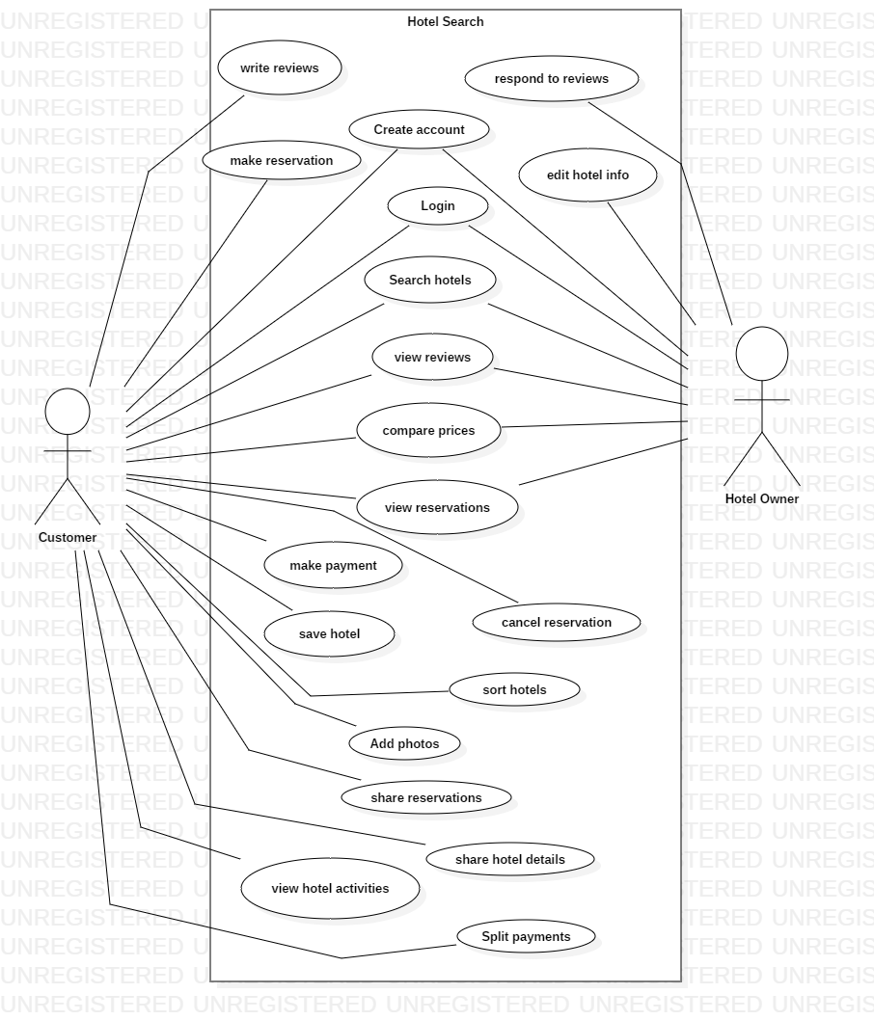Use Case Diagram:

Use Case Descriptions:

* Create account: allow user to enter their personal information to represent themselves in the program, including a password, first and last name, username, date of birth, email, address and phone number and optionally upload a photo. The account can be a standard account (for hotel searchers) or business (for hotel owners).
  + Allow user to fill in all fields
  + Check to ensure that the username is not taken
  + If taken, notify user to select different username
* Login: allow the user to enter their username and password to login
  + Check the username and password
  + If the username or password or not found, notify user
* Search hotels: allow user to enter location information to search for hotels in that area
  + Get hotels within some distance of the specified location to display in the list
  + If the location is not valid, notify user
* View reviews: allow user to view reviews of hotels on the hotel information page
  + Allow user to select the hotel
  + Display list of reviews for that hotel
* Write reviews: allow user to write a review for a hotel
  + Display textbox for text entry and allow user to select stars (out of 5) to rate their experience
  + If fields are left blank, notify user
* Compare prices: allow user to select multiple hotels to compare side-by-side
  + Select individual hotel
  + Select at least one additional hotel
  + Enable “compare” option to be selected showing hotels side-by-side
* View reservations: allows hotel owners to view all reservations for their hotel and hotel users to view their reservations
* Cancel reservation: allows users to cancel a reservation up to 24 hours after booking
  + User is already viewing reservation
  + Prompt user to ask if they are sure they want to cancel
  + Update reservation details on hotel owner-end
* Save hotel: allow user to add hotel to a list of saved hotels
  + Add hotel to user’s list
  + If the hotel is already on the list, prompt user and do not add to list
* Sort hotels: allow user to sort list of hotels in order based on price, distance from specified location, and user rating
  + Update list of hotels to reflect new condition
* Add photos: allow users to upload photos of hotels
  + When writing a review, have option for user to add photos
  + Allow user to select one or more photos from their device to upload along with the review
* Share reservations: allow user to share reservations via email
  + After reservation is made, offer user the option to share the reservation details
  + Prompt user for email address(es) they wish to send the information to
* Share hotel details: allow user to share hotels via email
  + Prompt user for email address(es) they wish to send the hotel details to
  + Generate a formatted email to send to the recipient
* View hotel activities: Allow user to view activities offered by the hotel or nearby the hotel
  + Display list of activities
* Split payments: When paying for a reservation, allow the user to split payments equally among the number of people staying in the room
  + Allow user to select split payment option
  + Let n = number of customers staying in room
  + Generate n number of fields to enter payment info
  + Display the total price for each payment field as the total cost divided by n

**SECTION 3: Specific Requirements**

|  |
| --- |
| **No:** 1 |
| The system shall require the user to input name, user name, password date of birth, email address, phone number, street address, zip code, and country when creating an account |
| **No:** 2 |
| The system shall prompt the user to enter username and password to login |
| **No:** 3 |
| The system shall display a list of hotels based on user-defined dates, price range, location, availability, rating, and stars |
| **No:** 4 |
| The system shall display a map of the hotels on the based on user-defined dates, price range, location, availability, rating, and stars |
| **No:** 5 |
| The system shall offer business accounts for hotel owners with the ability to edit all hotel information |
| **No:** 6 |
| When selecting a hotel, the system shall display user-written reviews |
| **No:** 7 |
| The system shall allow users to write reviews for hotels they have reserved after their reservation date |
| **No:** 8 |
| The system shall display hotels within +-20% of the selected hotel price on the hotel detail page within the user-defined radius |
| **No:** 9 |
| The system shall allow users to select an available room and make a reservation |
| **No:** 10 |
| The system shall allow users to cancel an existing reservation up to 24 hours after booking |
| **No:** 11 |
| The system shall allow users to a view a list of their existing and past reservations |
| **No:** 12 |
| The system shall allow the user to sort the list of hotels based on price, distance from location, stars, user rating, popularity |
| **No:** 13 |
| The system shall display nearby entertainment within user-defined proximity to hotel |
| **No:** 14 |
| The system shall allow hotel owners to view reservations |
| **No:** 15 |
| The system shall allow hotel owners to respond to user reviews |
| **No:** 16 |
| The system shall allow the user to share reservation details via email |
| **No:** 17 |
| The system shall allow users to split payments among the number of customers staying in the room(s) |
| **No:** 18 |
| The system shall allow users (specifically hotel customers) to upload hotel photos |
| **No:** 19 |
| The system shall allow users to save a list of hotels for future reference |
| **No:** 20 |
| The system shall allow users to share hotel details via email |

Template created by G. Walton ([GWalton@mail.ucf.edu](mailto:GWalton@mail.ucf.edu)) on Aug 30, 1999 and last updated Aug 15, 2000; updated by A. Koufakou, Aug 2014

This page last modified by Robert Darrow (rwdarrow4582@eagle.fgcu.edu) on October 12, 2018